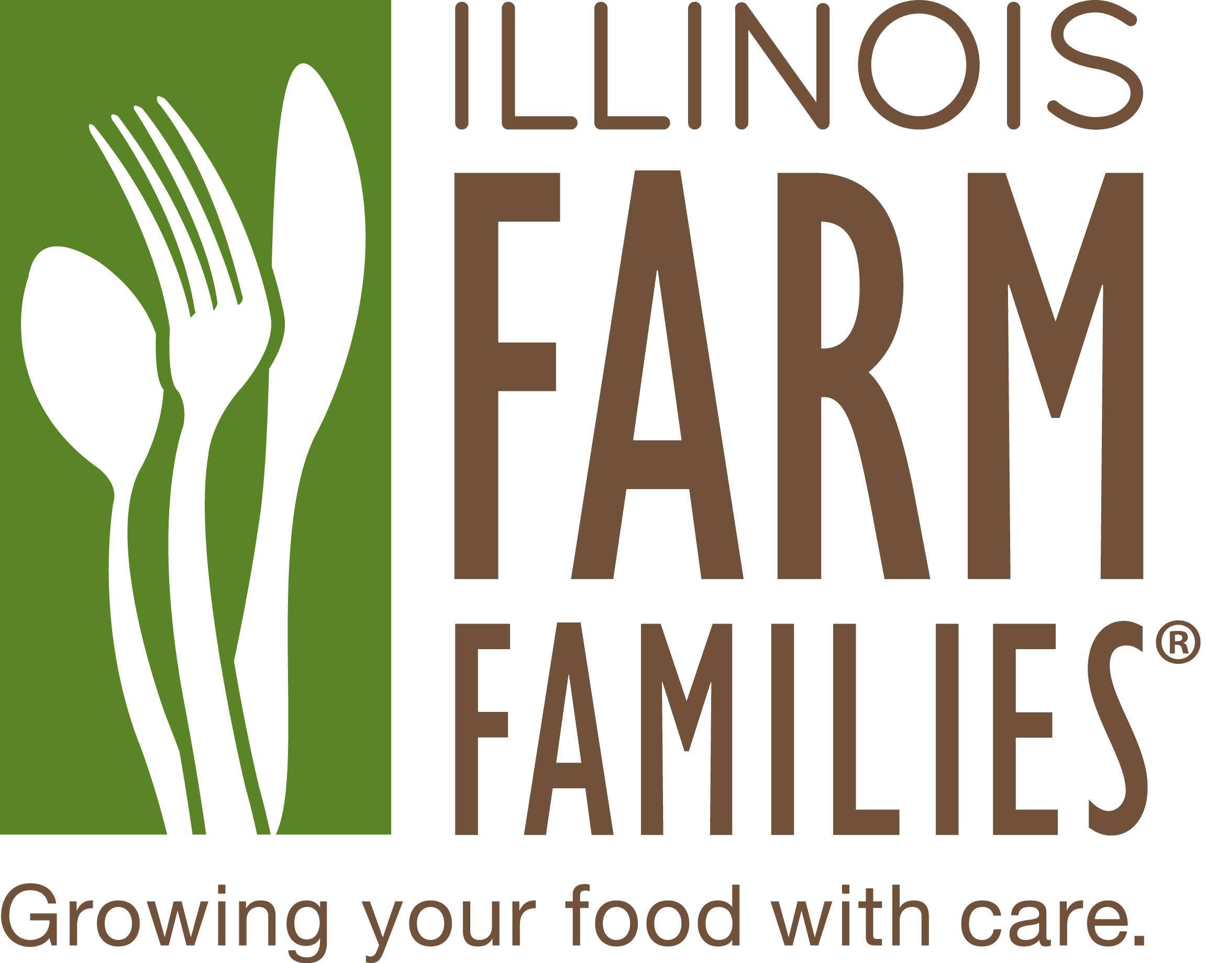

Terms you may hear on this tour
Cow-Calf farm: A farm that raises cows for breeding. When a calf is born, it weighs between 60 and 100 pounds. For the first few months, calves will live off their mother’s milk and graze on grass in pastures.
Bovine: An animal related to cattle.
Cow: Female bovine animal that has had a calf.
Heifer: Young female bovine animal that has not had a calf.
Steer: A castrated male bovine animal.
Parturition: Giving birth; calving.
Calving season: The season(s) of the year when the calves are born.
Weaning: Transitioning calves from mother’s milk to grass. Beef calves are weaned between 6 and 10 months when they weigh about 450 to 700 pounds.
Ear tag: An individual identification tag for each animal.
Feedlot: For some cattle, the last stop in the process, where they are fed grain and other feed ingredients for 90 to 120 days before they go to market. Feedlots range in size from less than 100 animals to many thousands.
Feedyard: Cattle-feeding facility.
Finish: The last feeding phase of cattle before market.
Marbling: Flecks of unsaturated fat found in muscle tissue. Marbling is usually evaluated in the rib-eye between the animal’s 12th and 13th ribs. It is a major factor in assigning USDA quality grade of a beef carcass.
USDA grades: United States Department of Agriculture grades that relate to a specified quality of product. Grade denotes quality and USDA denotes product inspected for wholesomeness.
Certified organic: Organic certification is a certification process for organic food and other organic agricultural products.
Grass fed: Refers to meat from cattle that eat mainly grass throughout their life.
Grain fed: Refers to meat from cattle that eat a mix of grain with hay or straw during the last four to six months before going to market.

